6_ Demonstrate inter vlan routing.
AIM: Demonstrate inter vlan routing.
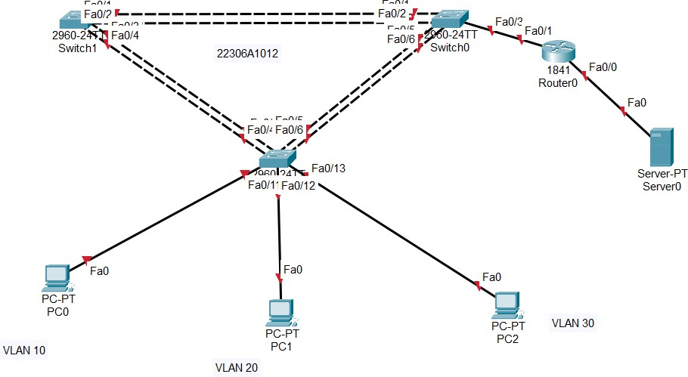

Task1: check VLAN config in each switch type command for all switches:
en
show vlan br
CHECK IF ALL SWITCHES HAVE SAME VLAN (1002,1003,1004,1005...)
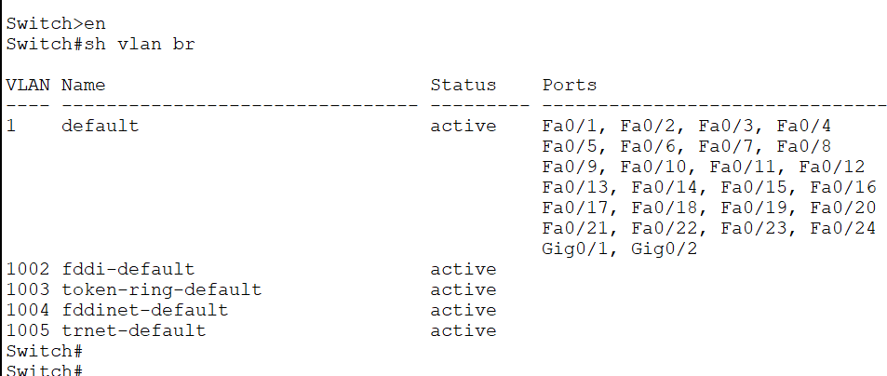

Task2: disable all ports on all the switches commands for all switches:

conf t
interface range fa0/1-24 shutdown
interface range gi0/1-2 shutdown
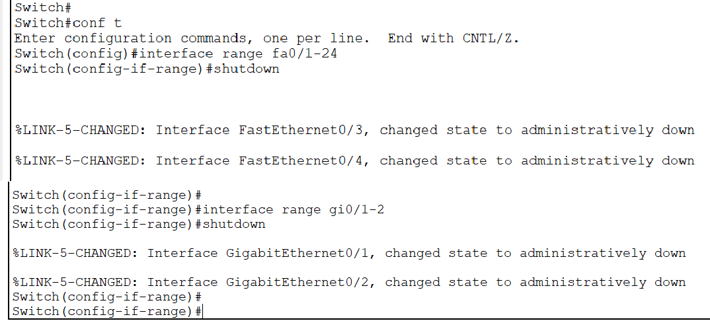

Task3: Perform basic switch configurations like assign name to switches, password to switches as well as gateways.
commands for all switches: exit
(config)
hostname s0 enable secret class
no ip domain-lookup
ip default-gateway 172.17.99.1
line console 0 (config-line) password cisco login
line vty 0 15 password cisco login
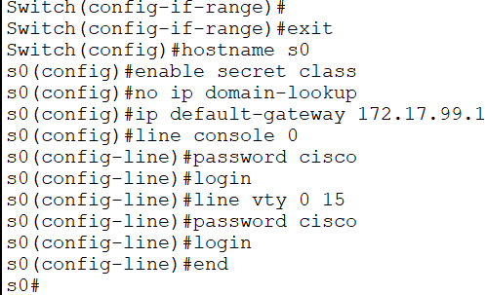
end

Task4: On the interfaces of the switch 2 connect it to the PCs, configure access mode and enable
commands for s2:
(config) int fa0/11 (config-if)
switchport mode access no shutdown

int fa0/12
switchport mode access no shutdown

int fa0/13
switchport mode access no shutdown
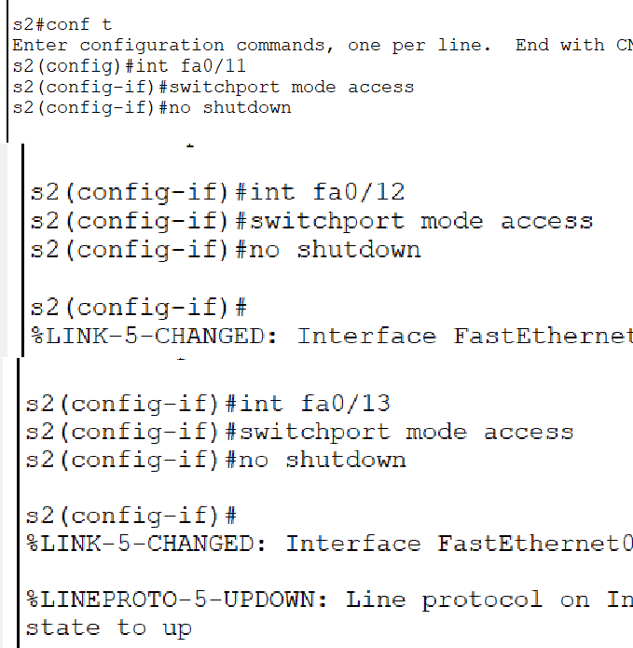

Task5: Configure IP addresses on the three PCs and the server

PC0-> Desktop -> IP config IP: 172.17.10.21 255.255.255.0
Default gateway: 172.17.10.1

PC1-> Desktop -> IP config IP: 172.17.20.22 255.255.255.0
Default gateway: 172.17.20.1

PC2-> Desktop -> IP config IP: 172.17.30.23 255.255.255.0
Default gateway: 172. 17.30.1

Server -> Desktop -> IP config IP: 172.17.50.254 255.255.255.0
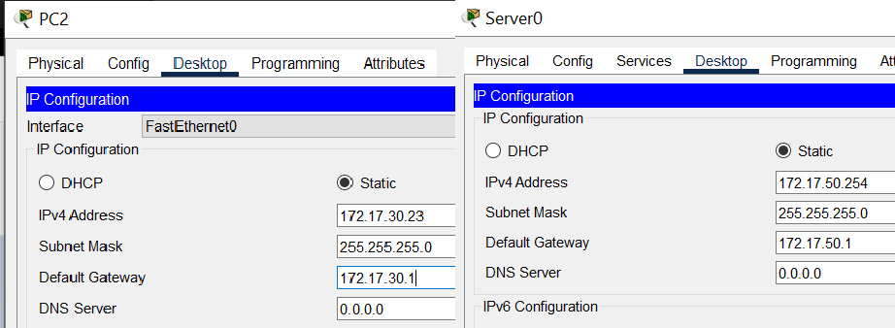
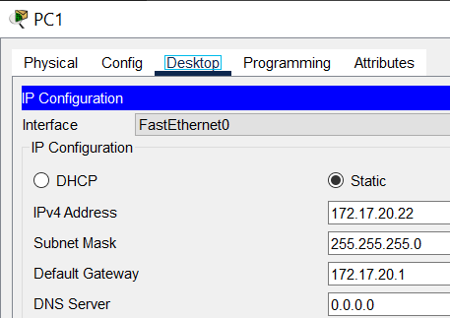
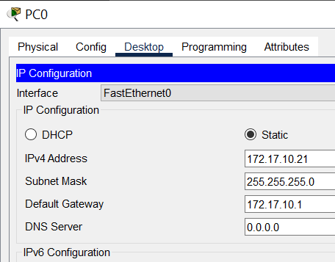
Default gateway: 172.17.50.1

Task6: Configure VTP protocol on the switches. s0 will be VTP server, s1 & s2 will be VTP client
s0:
Password: class en
(#)
Password: conf t (config)
vtp mode server vtp domain vsit vtp password cisco s1:
Password:
en #
Password: conf t (config)
vtp mode client vtp domain vsit vtp password cisco s2:
Password:
en #
Password: conf t (config)
vtp mode client vtp domain vsit vtp password cisco
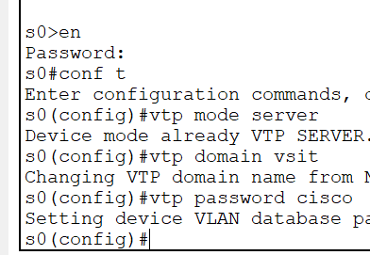

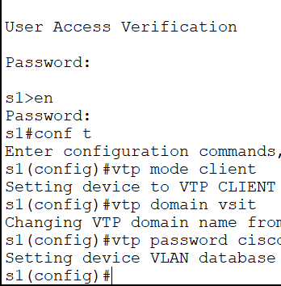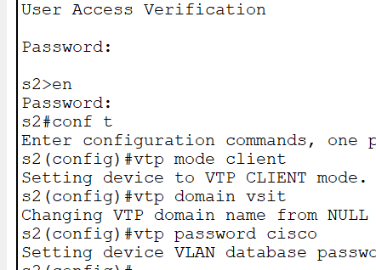

Task7: Configure trunking codes on all connections between switches and enable them

s0:
(config)
int range fa0/1-3 (config-if)
switchport mode trunk switchport trunk native vlan 99 no shutdown

int range fa0/5-6 switchport mode trunk
switchport trunk native vlan 99 no shutdown

s2:
(config)
int range fa0/3-6 (config-if)
switchport mode trunk switchport trunk native vlan 99 no sh

s1:
(config)
int range fa0/1-4 (config-if)
switchport mode trunk switchport trunk native vlan 99

no sh

s0:
(config-if-range) exit
(config) vlan 99
name management (config-vlan)
vlan 10 name staff vlan 20
name students vlan 30
name guests

exit
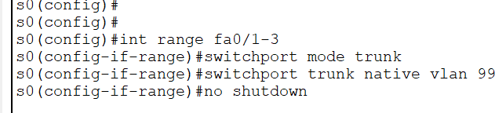
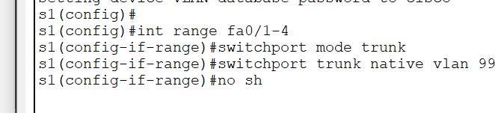
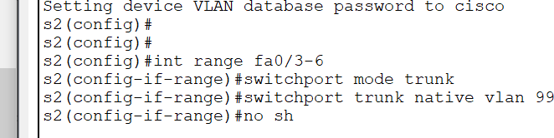
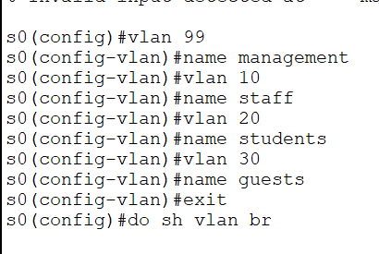
do sh vlan br (On s0 and s2)

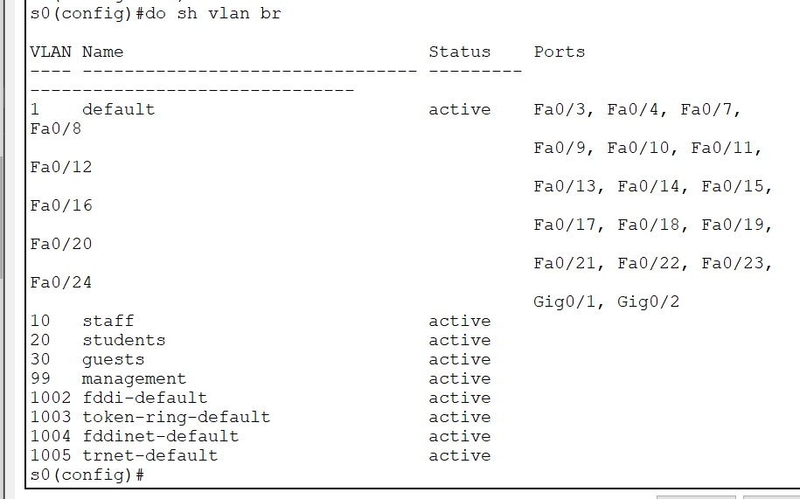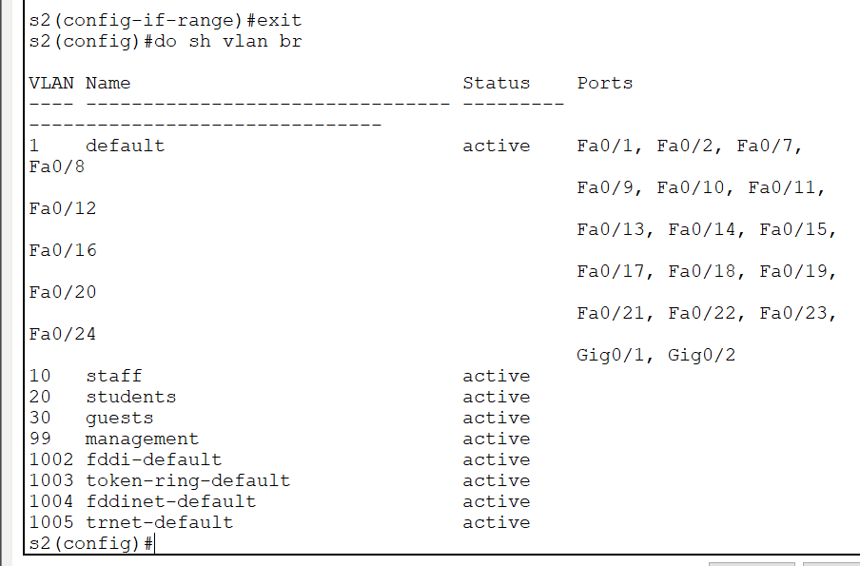

Task8: Configure interface vlan 99 on all the switches

s0:
(config) int vlan 99 (config-if)
ip add 172.17.99.11 255.255.255.0

end

s2:
(config) int vlan 99 (config-if)
ip add 172.17.99.12 255.255.255.0
end

s1:
(config) int vlan 99 (config-if)
ip add 172.17.99.13 255.255.255.0
end
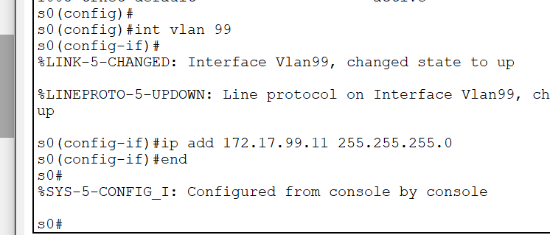
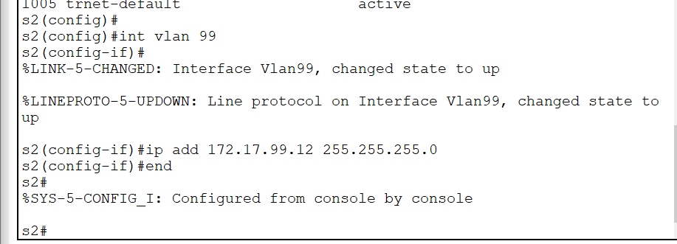
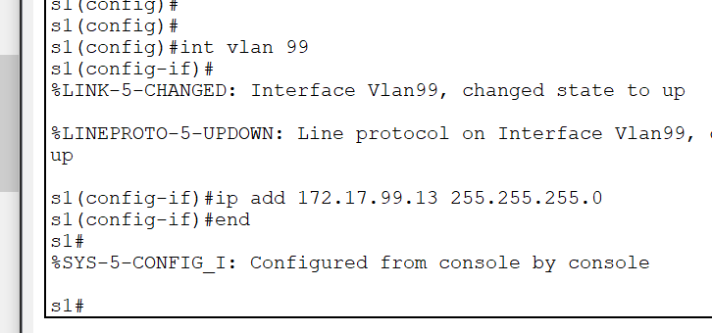

Task9: Configure vlan 10, vlan 20 and vlan 30 on switch 2
s2:

(config) int fa0/11 (config-if)
switchport access vlan 10 int fa0/12
switchport access vlan 20 int fa0/13
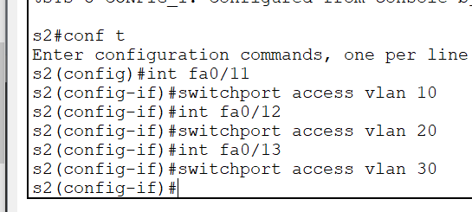
switchport access vlan 30

Task10: perform configuration on router
Router:
en conf t
hostname r1
no ip domain-lookup line console 0 (config-line) password cisco
login
line vty 0 15 password cisco login
end

conf t (config)
enable secret class int fa0/1
no sh

int fa0/1.1 (config-subif)
encapsulation dot1q 1
ip add 172.17.1.1 255.255.255.0
int fa0/1.10 encapsulation dot1q 10
ip add 172.17.10.1 255.255.255.0
int fa0/1.20 encapsulation dot1q 20

ip add 172.17.20.1 255.255.255.0
int fa0/1.30 encapsulation dot1q 30
ip add 172.17.30.1 255.255.255.0
int fa0/1.99
encapsulation dot1q 99 native
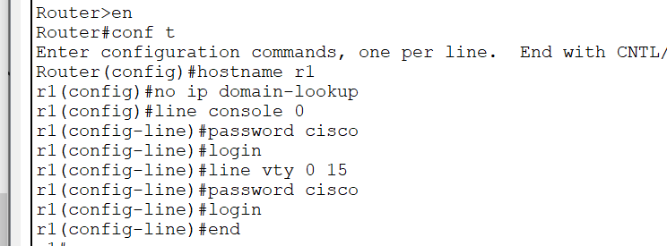
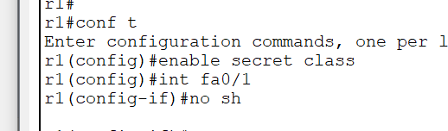
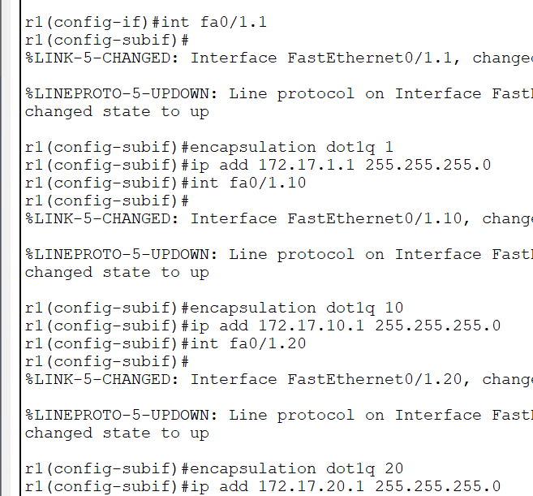
ip add 172.17.99.1 255.255.255.0

